**Project Code**

**STUDENT INFORMATION SYSTEM:**

#include <stdio.h>

#include <stdlib.h>

#include"student.data.h"

// Structure to represent student information

struct Student

{

char name[15];

char father_name[20];

char phone_no[30];

char grade[5];

char address[40];

int attendence;

int rollNumber;

float marks;

};

// Function to add student information

int addStudent(struct Student students, int count)

{

printf(" \n ENTER STUDENT INFORMATION AS GIVEN \n");

printf("1.Enter student name: ");

scanf_s("%s",&students.name, 15);

printf("2.Enter student phone Number:");

scanf_s(" %s", &students.phone_no, 30);

printf("3.Enter the student Grade:");

scanf_s(" %s", &students.grade, 5);

printf("4.Enter student total marks: ");

scanf_s("%f", &students.marks);

printf("5.Enter Student Father Name:");

scanf_s("%s",&students.father_name,20);

printf("6.Enter student roll number: ");

scanf_s("%d",&students.rollNumber);

printf("7.Enter Student Attendence:");

scanf_s("%d", &students.attendence);

printf("8.Enter Student Home Address:");

scanf_s("%s", &students.address, 40);

FILE* f;

fopen_s(&f, "C:\\student data\\abc.txt", "a");

if (f == NULL)

{

printf("Error Opening File.......\n");

}

fprintf(f,"%s %d %s %f %s %s %d %s",

students.name,students.rollNumber,students.phone_no,

students.marks, students.grade, students.address,

students.attendence,students.father_name);

fclose(f);

return (count)++;

}

// Function to display all student information

void displayStudents(struct Student students, int r)

{

printf("\nStudent Information:\n");

for (int i = 0; i < r; i++)

{

printf("Name: %s\n", students.name);

printf("Father Name:%s", students.father_name);

printf("Roll Number: %d\n", students.rollNumber);

printf("Marks: %.2f\n", students.marks);

printf("Phone Number:%s", students.phone_no);

printf("Grade:%s", students.grade);

printf("Address:%s", students.address);

printf("Attendence:%d", students.attendence);

printf("\n");

printf("*******************************************\n");

}

}

int main()

{

int select,r;

int count = 0;

struct Student students[50];

do

{

printf(" ***MENU OF STUDENT INFORMATION SYSTEM***\n");

printf("\n");

printf("Select 1 to add Students Information\n");

printf("Select 2 to Display Students Information\n");

printf("Select 3 to Exit\n");

printf("Select any one[1,2,3]: ");

scanf_s("%d",&select);

switch (select)

{

case 1:

if (count < 50)

{

r=addStudent(students[50],count);

printf("Information added successfully!\n");

}

else

{

printf("Maximum number of students reached!\n");

}

break;

case 2:

displayStudents(students[50],r);

break;

case 3:

printf("Exiting the program. Goodbye!\n");

break;

default:

printf("Invalid choice. Please try again............\n");

}

} while (select != 3);

data();

return 0;

}

#pragma once

void data()

{

printf("PROGRAM RUNS SUCSESSFULLY");

}

**OUTPUT:**

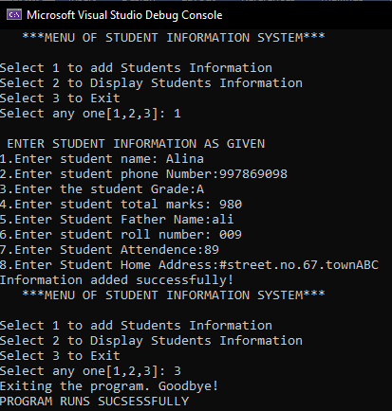

**DATA STORED IN abc FILE:**

